MODULE-4
QUESTION AND ANSWER:1
https://www.hackerearth.com/problem/algorithm/digit-sum-4/
#include <stdio.h>

int main()
{
int t, n, first, last;

scanf("%d", &t);

while (t--)
{
scanf("%d", &n);

last = n % 10;

while (n >= 10)
{
n = n / 10;
}

first = n;

printf("%d\n", first + last);
}

return 0;
}


MODULE-4
QUESTION AND ANSWER 2:
https://www.hackerrank.com/challenges/find-digits/problem
#include <stdio.h>
int main()
{
int t, n, temp, digit, count;
scanf("%d", &t);
while (t--)
{
scanf("%d", &n);
temp = n;
count = 0;
while (temp > 0)
{
digit = temp % 10;
if (digit != 0 && n % digit == 0)
{
count++;
}
temp = temp / 10;
}
printf("%d\n", count);
}
return 0;
}


MODULE-4
QUESTION AND ANSWER 3:
https://leetcode.com/problems/subtract-the-product-and-sum-of-digits-of-an-integer/description/
int subtractProductAndSum(int n) {
int sum = 0;
int product = 1;
int digit;

while (n > 0) {
digit = n % 10;

sum = sum + digit;
product = product * digit;

n = n / 10;
}

return product - sum;
}
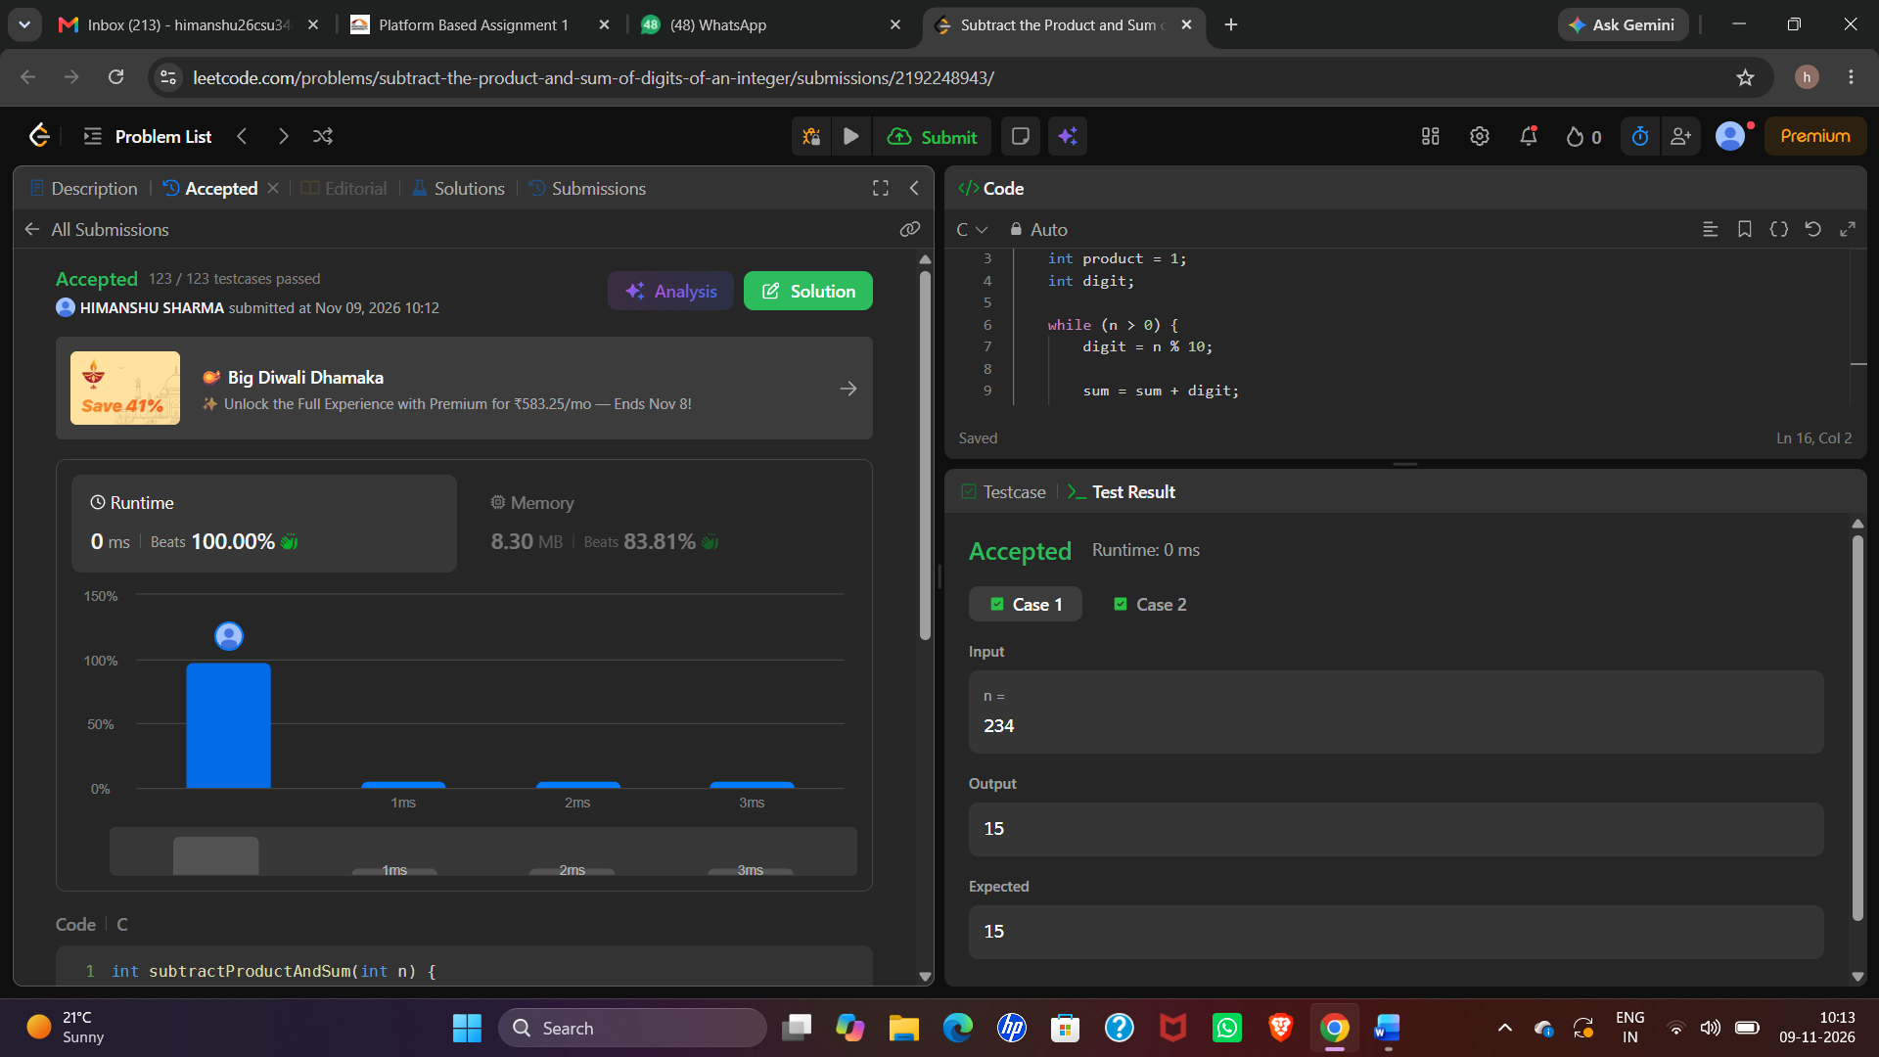
MODULE-4
QUESTION AND ANSWER 4:
https://leetcode.com/problems/count-the-digits-that-divide-a-number/
int countDigits(int num) {
int temp = num;
int digit, count = 0;

while (temp > 0) {
digit = temp % 10;

if (num % digit == 0) {
count++;
}

temp = temp / 10;
}

return count;
}
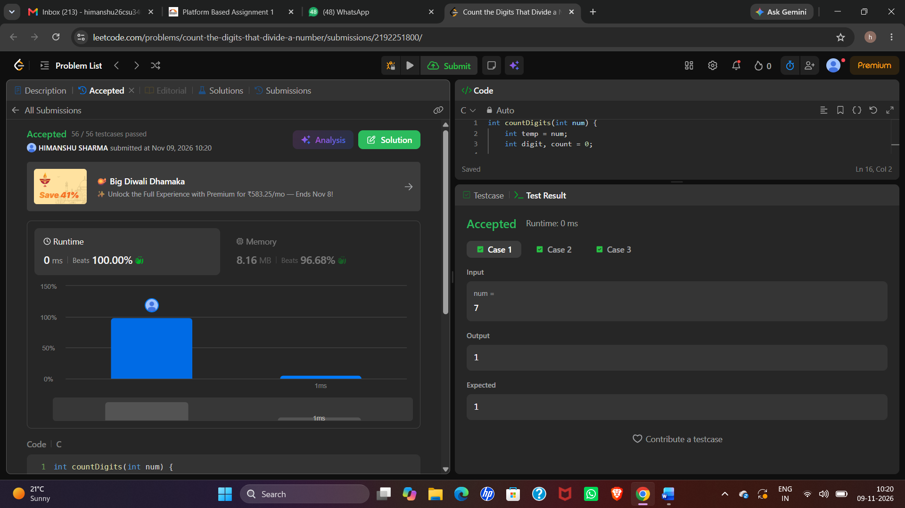
MODULE-4
QUESTION AND ANSWER 5:
https://leetcode.com/problems/palindrome-number/
bool isPalindrome(int x) {
int original = x;
long reverse = 0;

if (x < 0) {
return false;
}

while (x > 0) {
int digit = x % 10;
reverse = reverse * 10 + digit;
x = x / 10;
}

return original == reverse;
}
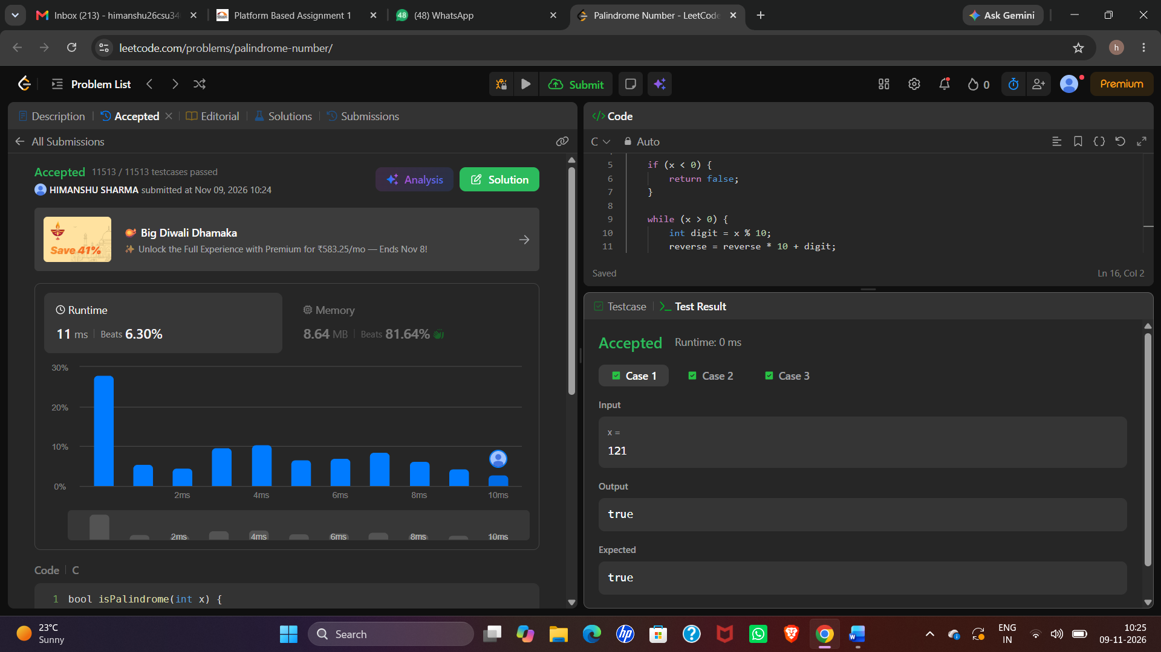
MODULE-4
QUESTION AND ANSWER 6:
https://leetcode.com/problems/reverse-integer/
int reverse(int x) {
int rev = 0;
while (x != 0) {
int digit = x % 10;
if (rev > INT_MAX / 10 ||
(rev == INT_MAX / 10 && digit > 7)) {
return 0;
}
if (rev < INT_MIN / 10 ||
(rev == INT_MIN / 10 && digit < -8)) {
return 0;
}
rev = rev * 10 + digit;
x = x / 10;
}
return rev;
}



